Dear @Khaled Khalil,

Kindly align the resource for the below mentioned issue:

It has been observed that the FR doesn’t sync with the Inventory report.

Example:

The same TAG has different SN showing in Inventory and FR.
Ideally the SN of inventory should get sync with the FR,

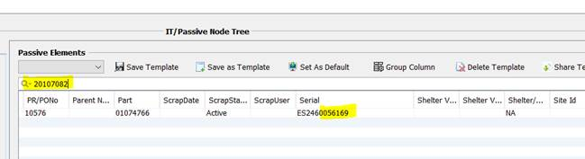

FR

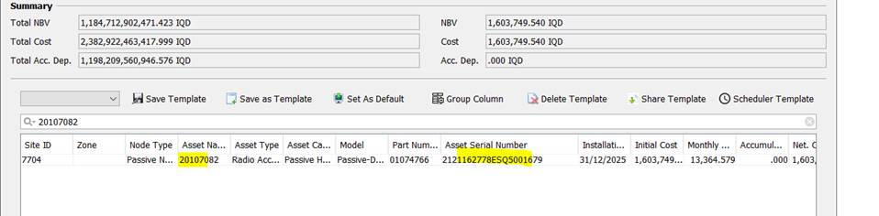

Also, it has been observed that the SN is not present in the Inventory report showing Delete “no” in FR.

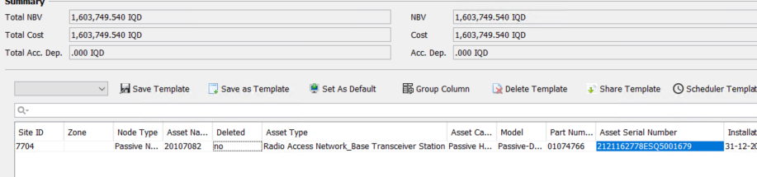

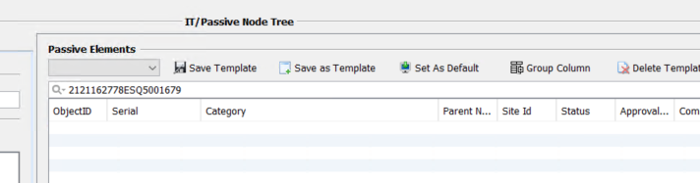

More cases like that :

S.N | Tag | S.N
ES2460056169 | 20107082 | 2121162778ESQ5001679
ES2450044958 | 20107081 | 2133010007CJQ3007400
ES2450044973 | 10113638 | 2121162778ESQ4001593

